

As part of the interview process for this role, we invite you to complete a written exercise. Written and verbal communication skills are critical for success at Amazon. We recognise that some candidates may express themselves better through writing, while others express themselves better verbally. We’d like to give you an opportunity to do both.

Grading Criteria:
- Clarity of thought and expression (i.e., did you explain your point well?)
- Organization and structure (i.e., does it flow? does it make sense?)

Guidelines:
- Please respond in narrative form and limit the use of bullets/outline form.
- Please type your response in rich text format (i.e., MS Word).
- Your written exercise should not exceed two A4 pages.
- Please clearly indicate the question you have selected at the top of your response.
- Please do not include any confidential or proprietary information.

The submission date will be 1-2 business days in advance of your interview (a specific deadline will be provided separately). You may or may not be directly asked about your
written exercise question during your on-site interview. Please note that your submission
will be reviewed by members of the interview team during our final review. All offers
extended by our recruiting team are contingent upon receiving a written response.

It’s important that the written response you submit is your own. So, by submitting your response to the written interview question, you acknowledge that it was prepared solely by you. You acknowledge that you did not consult anyone, use any other resource in order to respond, and did not receive any contribution from a third party source. In addition, please be sure you do not share any confidential information that may be protected by your current/past employers.

CANDIDATE ANSWER FORM
Candidate Name: Michelle Govindsamy
Role Applied For: Senior Finance Business Partner Amazon UK Services Ltd. Job ID:1165661
Interview Date:
Written Exercise Deadline Date:

Option 2:
What is the most inventive or innovative thing you have done? Describe something that was your idea, e.g. a process change, a product idea, a new metric, or a novel customer interface. It does not need to be something that is patented. Do not write about anything your current or previous employer would deem confidential information. Provide relevant context for us to understand the invention/innovation. What problem were you seeking to solve, and what was the result? Why was it an important problem to solve? How did it make a difference to the business or organization?

Answer:

In March 2016, I joined the Loyalty and Rewards Business team of Barclays Africa as the Head of Commercial Modelling and Analytics. The first matter to be addressed was the cost of the program and inefficiency to drive customer behaviour. This was a significant task as it meant a complete product overhaul.
It was the responsibility if the analytics work stream to provide the optimal program structure, the cost and customer impact of any changes, as well as, the data to assist the steering committee in making appropriate decisions. The risks to be considered were, being too aggressive on cost saving thus making the program unattractive to customers, alternatively, giving away too much value without the reciprocal increase in profit from a deeper customer relationship.
This exercise had not been performed in the 8 years of the programs existence. A blueprint did not exist. I spent some time brainstorming, researching and collaborating with colleagues and thought leaders in industry. This research led me to putting together a best practice roadmap on how to make the change.
My key approach was to build a simulation model of how customers and cost would be impacted by program changes. The model had to be flexible to run different scenarios and produce well visualised outputs with speed. Key was for the model to become an analytics capability opposed to a one-off calculation, a capability that could be used to understand future changes.
I scoped and briefed the requirements to the analytics team. I engaged with the Technology and Management Information teams to build a database of new information required to build the model. I engaged with the operations team to build this modelling capability in a test environment.
With this clarity, of where we would begin, the project came alive. All in all, it was weeks of, product development, analysis, Steering committee meetings, frontline training, amending marketing material and system changes. The new program was launched in March 2017.
The cost of the program reduced by 50%. Customer engagement with the program increased. The program was more closely aligned with the organisations overall strategy.
The analytics methodology and capability developed allowed for frequent future changes and enabled us to be quicker to market. It was used throughout the program to reshape other customer offerings.
I presented this approach at the 2018 Credit and Decision Analytics Conference hosted by Compuscan under the title, “Sweating the Loyalty Asset: Turning Rewards programs into key business tools to drive value.”
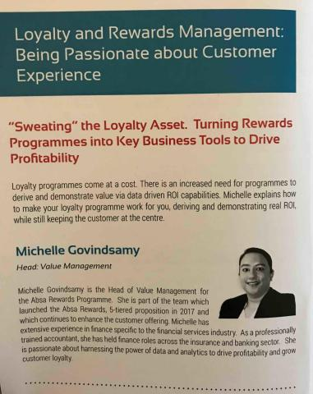
Thank you!

